Dear Sir/Madam

I hereby give you notice that the meeting of the above-named Town Council will be held on **Tuesday 4th 2025** at March Tidworth Civic Centre, Tedworth Hall, SP9 7QQ at 7:00pm.

All members of the Council are hereby summoned to attend for the purpose of considering and resolving upon the business to be transacted at the meeting as set out hereunder.

Dated this day 26th February 2025

Signed:

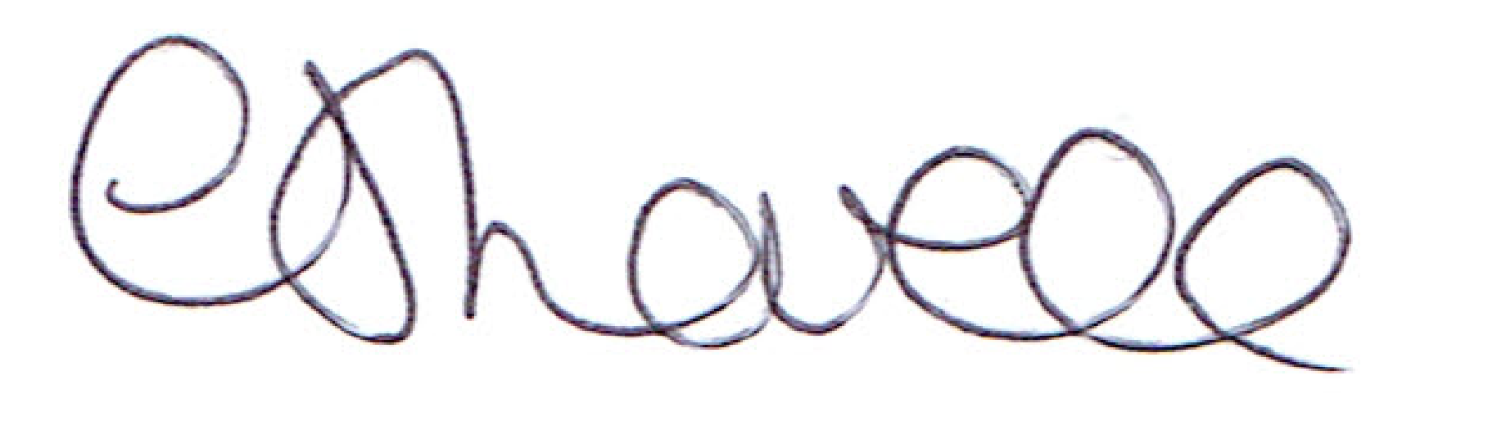

Mrs C Lovell, Clerk

|  |  |  |
| --- | --- | --- |
|  | **Agenda** | **Who?** |
| 1 | **Apologies for absence** | All |
| 2 | **Declaration of interest** | All |
| 3 | **General Public Questions allocated time 15mins** |  |
| 4 | **Minutes of February 2025 meeting.**  **Matters arising** |  |
| 5 | **Wiltshire Councillor’s Report** | MC/AP |
| 6 | **Mayors Report** | CW |
| 7 | **Committee Reports**   * **Community Services** to include Civic Centre and Cemetery, Riverbank fencing and hanging basket expenditure. * **Community Engagement** to include events expenditure. * **Projects** to include Civic Centre update and expenditure | PH  LC |
| 8 | **Co-Options** | All |
| 9 | **S137 Grants – Nepalese Community** | All |
| 10 | **Youth Street Worker** | CW |
| 11 | **Correspondence and Updates** | All |
| 12 | **Bills for payment** | All |
| 13 | **Date of next meeting**  **1st April 2025** | **Agenda items to the Clerk 7 days before meeting** |