Risk Management Policy
  - Background

  - Risk is an uncertain event or condition that, if it occurs, will have an effect on the achievement of Tidworth Town Council’s (hereafter known as the Council) objectives. Risk management is the process whereby the Council methodically address the risks associated with what it does and the services it provides. The focus of risk management is to identify what can go wrong and take proportionate steps to avoid this, or successfully manage the consequences.
1.2. Risk management is not just about financial management; it is about protecting the achievement of objectives set by the Council to deliver high quality public services. The failure to manage risks effectively can be expensive in terms of litigation and reputation, can impact on the ability to achieve desired outcomes. The authority generally and members individually are responsible for risk management.
1.3. Risk management is an ongoing activity that comprises four elements:
a) identifying risks.
b) assessing risks.
c) addressing risks; and
d) reviewing and reporting.
2. Identifying risks
2.1. In order to manage risk, the Council needs to know what risks it faces. Identifying risks is therefore the first step in the risk management process.
2.2. The Council will identify the key risks to successfully achieving its priorities and service objectives, in the following categories:
a) financial – loss of money.
b) security – fraud, theft, embezzlement.
c) property – damage to property.
d) legal – breaking the law or being sued.
e) IT – failure of IT systems or misuse; and
f) reputational – actions taken which could harm the Council’s public reputation.

3. Assessing risks
3.1. Having identified potential risks, the Council assesses the likelihood of them happening and the impact they would have. This allows the Council to identify the various levels of risk posed when considering the measures it should take.
3.2. Risk assessment matrix:
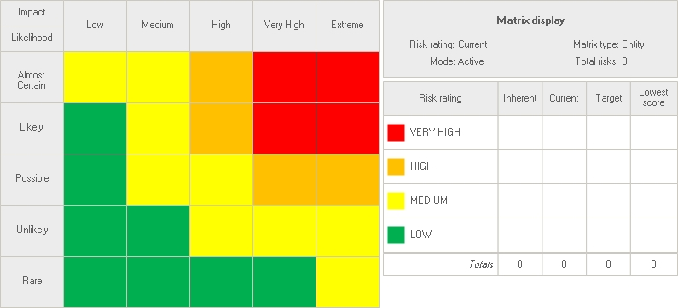

4. Assessing risks
4.1. Risk is unavoidable, and every organisation needs to take action to manage risk in a way which it can justify to a level which is tolerable. The response to risk, which is initiated within the Council, is called ‘internal control’ and may involve one or more of the following standard responses:
Tolerate | For risks that are containable, where the possible controls cannot be justified (e.g., They would be disproportionate) and where risks are unavoidable e.g., terrorism.
Treat | Imposing controls so that the organisation can continue to operate; or introducing measures to deal with the risk.
Transfer | Buying in a service from a specialist external body or taking out insurance. Some risks cannot be transferred, especially reputational risk.
Terminate | Avoiding or cancelling activities where no response can bring the risk down to an acceptable level.

4.2. The Council will use insurance to help manage risk including the following:
a) The protection of physical assets owned by the Council – buildings, furniture, equipment, etc. (loss or damage)
b) The risk of damage to third party property or individuals as a consequence of the Council providing services or amenities to the public (public liability).
c) The risk of consequential loss of income or the need to provide essential services following critical damage, loss or non-performance by a third party (consequential loss).
d) Loss of cash through theft or dishonesty (fidelity guarantee).
e) Legal liability as a consequence of asset ownership (public liability).
4.3. The limited resources available to the Council means that it works with specialist external bodies to help manage risk to include the following:
a) Security and maintenance for its buildings, amenities, or equipment.
b) The provision of services being carried out under agency/partnership agreements.
c) Accountancy.
d) Provision of amenities/ facilities for events.

5. Reviewing and reporting
5.1. Having identified likely risks, the Council records this in a Risk Register. This register is kept under review by the Responsible Financial Officer and is reported to the Policies and Procedures Committee for adoption by full town Council.

Signed: ______________________________________ Date:_____________
(Print Name) ______________________________ Chair Tidworth Town Council

