TIDWORTH TOWN COUNCIL
Staffing July 2026
Dear Sir/Madam
I hereby give you notice that the meeting of the Staffing Committee will be held at Tidworth Town Council Office at Tidworth Civic Centre, Wylye Road, SP9 7QQ on 21st July 2026 at 6.30pm
All members of the Committee are hereby summoned to attend for the purpose of considering and resolving upon the business to be transacted at the meeting as set out hereunder.
Dated this day 16th July 2026
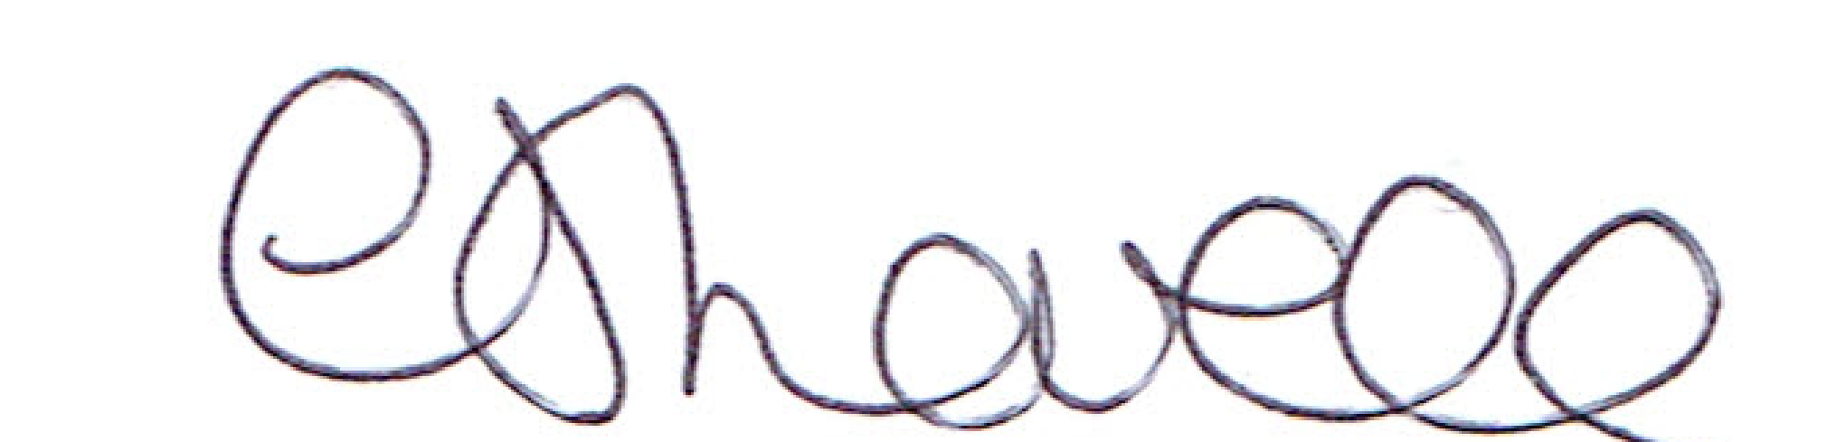
Signed: C Lovell, Clerk

Item | Agenda | Who?
1 | Staffing Committee Chair Election
2 | Consideration of Apologies for Absence
3 | Declaration of Interest | All
4 | Long term absence cover  Under the Public Bodies (Admission to Meetings) Act 1960 the above agenda items will be closed to the public due to its confidential nature. | All
5 | TBC  Agenda items to clerk 7 working days prior to meeting

