Dear Sir/Madam
I hereby give you notice that the meeting of the Leadership Committee to be held at Tidworth Civic Centre, Wylye Road on Wednesday 25th February 2026 @ 7pm.
All members of the Committee are hereby summoned for the purpose of considering and resolving upon the business to be transacted at the meeting set out hereunder.
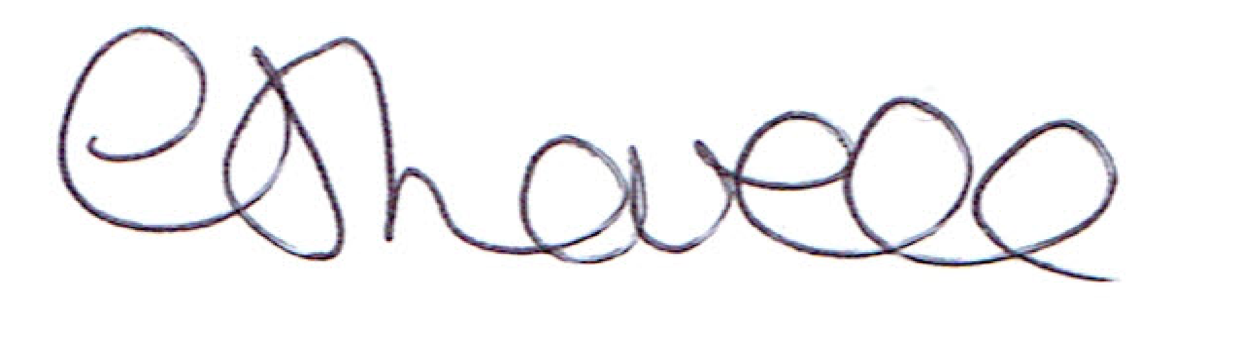
Dated:20^{h} February 2026

Mrs C J Lovell, Clerk
Item | Agenda | Who?
1 | Apologies for absence | All
2 | Declaration of Interest | All
3 | Civic Centre Management  Under the Public Bodies (Admission to Meetings) Act 1960 the above agenda items will be closed to the public due to its confidential nature. | All
4 | Café Lease  Under the Public Bodies (Admission to Meetings) Act 1960 the above agenda items will be closed to the public due to its confidential nature. | All
5 | Allotments – Tenancy agreement, update on planning.  Under the Public Bodies (Admission to Meetings) Act 1960 the above agenda items will be closed to the public due to its confidential nature. | All
6 | IT  Under the Public Bodies (Admission to Meetings) Act 1960 the above agenda items will be closed to the public due to its confidential nature. | RM/ALL
7 | Date of next meeting  TBC

